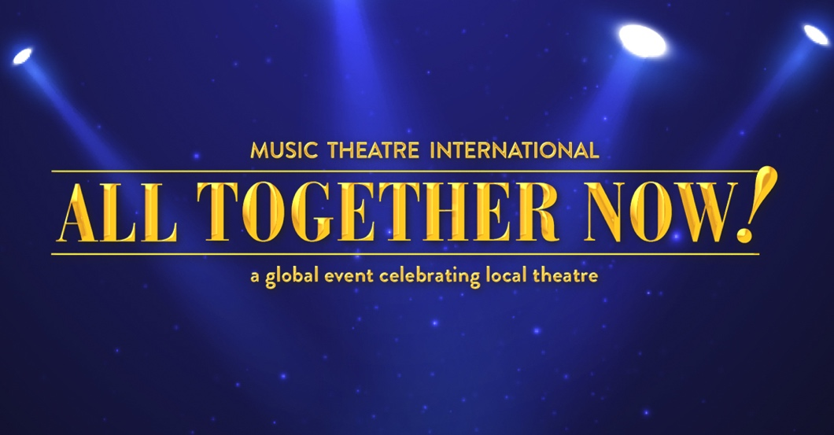

ORGANIZATION NAME Announces an Upcoming Production of

Music Theatre International’s
All Together Now!: A Global Event Celebrating Local Theatre

Performances to take place November 12 – 15, 2021

A fantastic selection of songs are featured in this brand new musical revue from shows including Rent, Les Misérables, Into the Woods, Matilda, Hairspray, Disney’s Beauty and the Beast, Fiddler on the Roof, Once on This Island, Little Shop of Horrors, Mamma Mia! and many more!

LOCATION, (DATE) – ORGANIZATION NAME announced that they will be joining thousands of theatrical organizations around the globe by producing their own local production of Music Theatre International’s All Together Now!: A Global Event Celebrating Local Theatre. Theatrical licensor Music Theatre International (MTI) created this revue for theatres across the globe to use as a local fundraising event performed over the same weekend of November 12, 2021. ORGANIZATION NAME’s performances are scheduled for DATES.

All Together Now! features songs from MTI’s beloved catalogue of musicals including Annie, Charlie and the Chocolate Factory, Come From Away, Disney and Cameron Mackintosh’s Mary Poppins, Disney’s Beauty and the Beast, Fiddler on the Roof, Godspell, Guys and Dolls, Hairspray, Into the Woods, Les Misérables, Little Shop of Horrors, Mamma Mia!, Matilda, My Fair Lady, Once on This Island, Rent, Waitress and many more!

OPTIONAL QUOTE TO INCLUDE FROM MTI:
- MTI’s President and CEO, Drew Cohen stated, “MTI’s All Together Now! is about bringing people back to the theatre, whether as audience members or cast, crew and musicians. The revue features songs from the world’s most iconic musicals, so there is definitely something for everyone to enjoy. Our goal with this worldwide event is for organizations to provide hope, inspiration and excitement to their communities through the transformative power of musical theatre.

LOCAL CUSTOMIZATION:
- THIS IS A GOOD PLACE TO INCLUDE INFORMATION ABOUT YOUR CAST, CREW, CREATIVE TEAM, ETC. YOU MAY ALSO WANT TO PROVIDE A QUOTE FROM YOUR LEADERSHIP:

SAMPLE QUOTE FROM YOUR LOCAL LEADERSHIP:
- “We are incredibly excited to celebrate the return of live theatre with performances of MTI’s All Together Now!,” stated NAME/TITLE/ORGANIZATION NAME. “The past year has been a challenging time for everyone, particularly arts organizations. We look forward to welcoming our patrons back with this truly wonderful revue.”

LOCAL CUSTOMIZATION FOR TICKET INFO:
- END THE PRESS RELEASE WITH INFORMATION / LINKS TO TICKET INFO.

